**EXPERIMENT 5**

Write a shell script and a C program to perform the following string operations:

1. To extract a substring from a given string

>Shell script

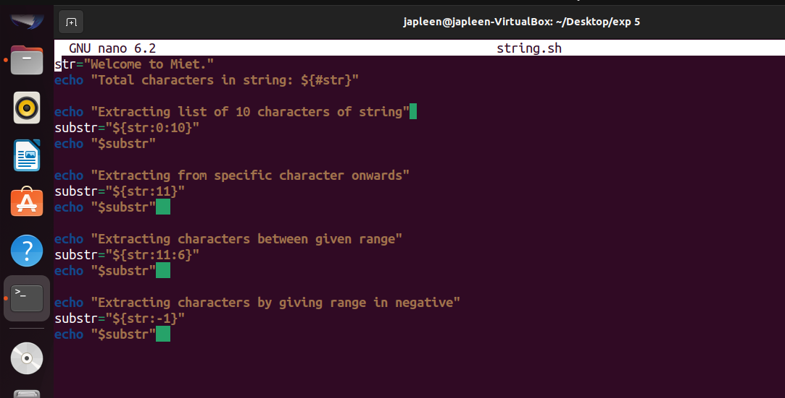

>C-Program

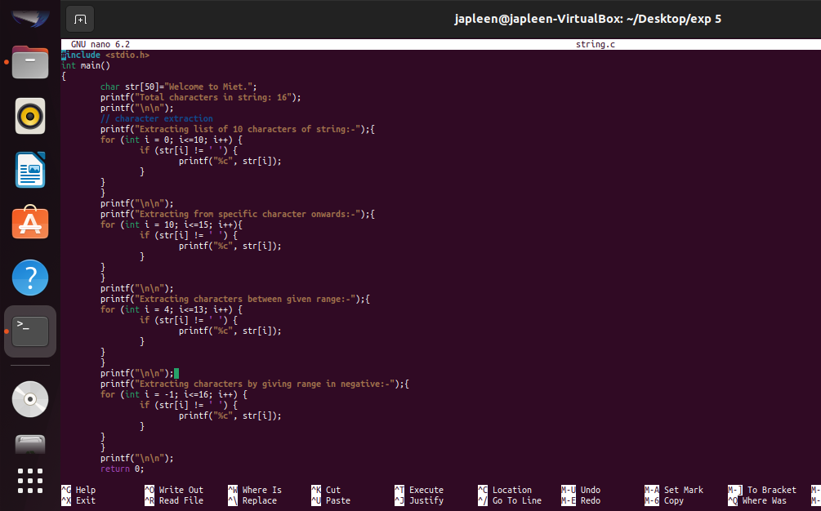

>Output using time command for

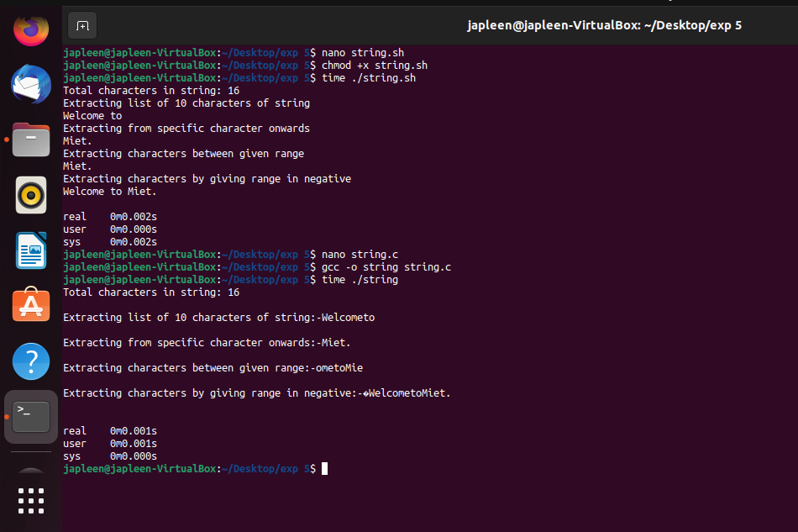

1. To find the length of a string

>Shell Script

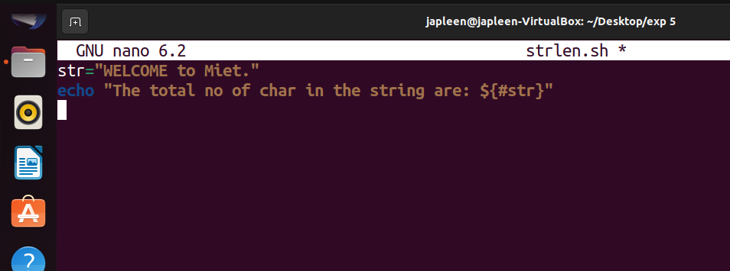

>C-Program

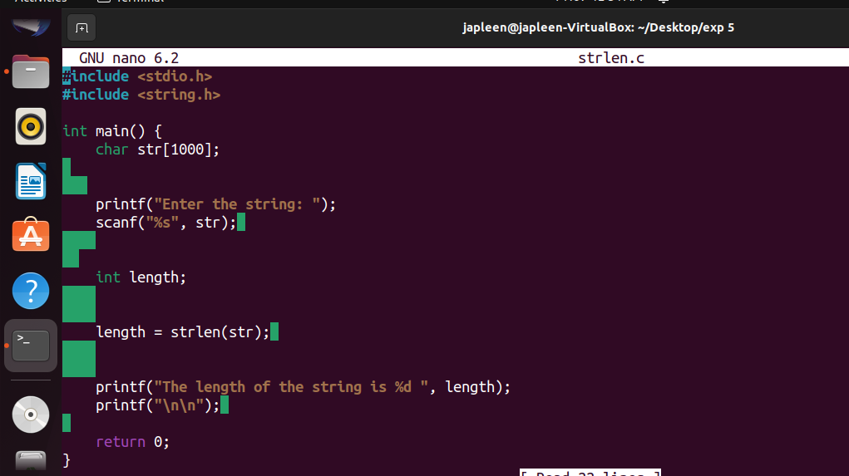

>Output using time command for both c program and shell script

